Task No 01: Create a visiting card using MS publisher.
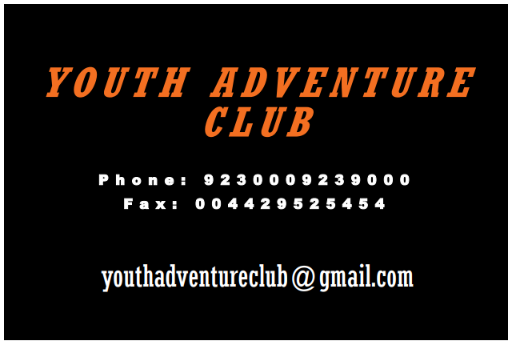
Task No 02: Create a Brochure using MS publisher.
